Sergio Duarte
19 November 2018
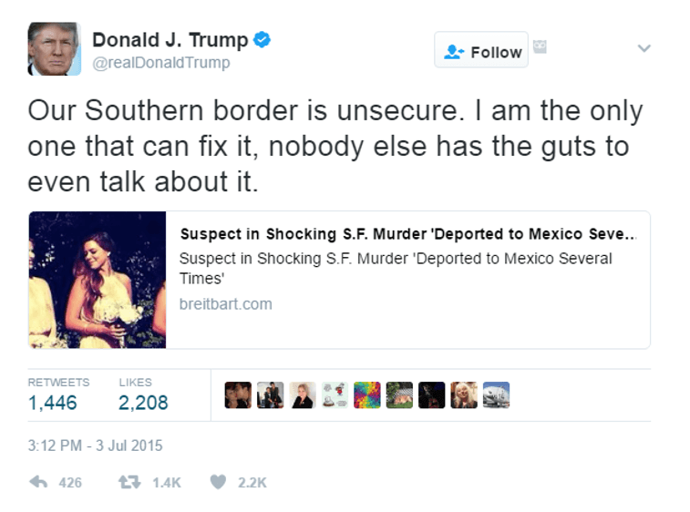
WP3

The South is unsafe
I have the right solution
Others do not speak

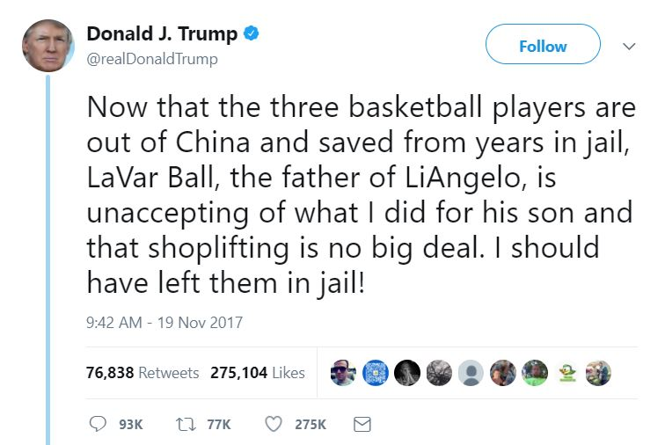

Three athletes rescued
The father will not thank me
They should have suffered

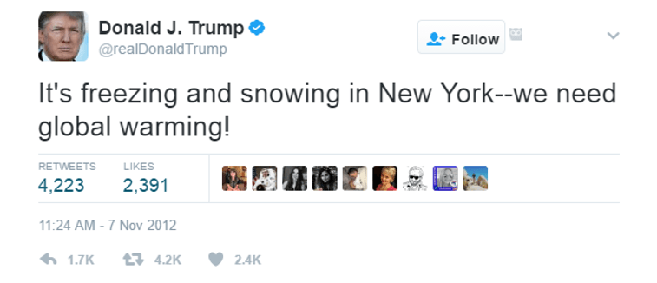
White snow is falling
If the Earth were heating up
It would not be so
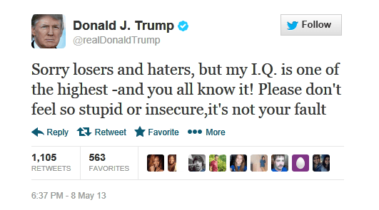

Apologies foes
My brain is superior
But don’t blame yourself

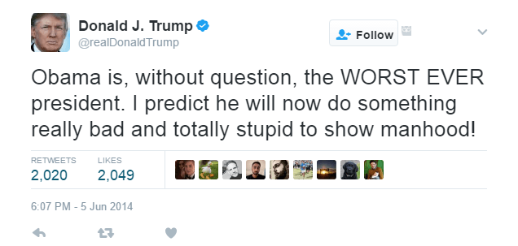

The man before me
The worst president ever
Will show foolishness

In my genre translation, I decided to transform the tweets of the president of the United States into the famous haiku-style poems. Both of these genres are very short, so there was not much information to be translated. The shortness also made translating a tweet to a haiku a lot more simple, since no information or key points had to be drastically condensed. The translation was fairly simple, but there were some challenges that arose. I chose these two genres because of the familiarity I have of both of them. Doing these translations shed a light on the similarities and differences between the two genres. Although they are similar in length, the seriousness that comes with the artistic haiku is greater than the seriousness— or lack of— a tweet.
Twitter consists of generally short sentences and ideas that are posted for the world to see. Trump’s 55+ million followers are all following him for one purpose: to see what he talks about next. Some audiences take Trump’s tweets seriously and support him, while others make fun of them or are angered by them. Therefore, the intended audience for his tweets are people even slightly interested in politics. As for his actual tweets, they sometimes contain political writing and terminology, but are mostly the ramblings of the mind of the untamed mind. Trump’s audience are part of what makes a tweet a tweet; people don’t look for deep significance in a tweet, so he just says whatever.
Haikus on the other hand have a smaller intended audience. The intended audience for haikus is the group of people that are interested in poetry. This audience is vastly different from the social media audience that Trump has. Haikus are a form of art, while people log on to Twitter just to kill some time. Audiences of haikus look for a deeper meaning in the words and phrases that make up the poem.
The difference between these two audiences means I had to think about the word choices in my translations. For example, when I wrote “Others do not speak”, I attempted to make the key point of his tweet sound more artistic with the flow of the words that I used. Trump isn’t known for using the most intellectual language, whereas haikus use words that aren’t common in everyday language. These word choices and the syntax into which I placed them helped accomplish this more serious and artistic tone.
The translation of tweets to haikus worked well because I was able to communicate the same information that Trump does in his tweets. The new audience I was trying to reach looks for artistic language and descriptive words. As long as I integrated those two aspects of poetry into the key message of his tweets, the translation process would work out fine. I thought that the new genre would communicate the same information effectively because of the length of both of the genres being similar.
That being said, the translations did not work out fine on my first attempts. Some of the first haikus that I originally wrote did not quite convey the same information. I was simply taking the words in the tweets and using a thesaurus to change the words to sound artistic, which did not result in the key message being communicated. After I realized I was failing in this aspect, I wrote down each main point and wrote those into phrases that met the 5-7-5 format of a haiku. I identified the main points of the tweet by taking out the main subjects of each sentence. Then, I changed the words to fit in to a five or seven syllable phrase that conveyed the same information. Since haikus can be about literally anything, all I had to do was follow the template of a haiku and insert the main points.
Not all information was kept in the process. For example, I left out names and places to be translated because they weren’t the key aspects of the tweet. In the case of the Obama tweet, I just described Obama instead of just saying his name. The names and places would have taken up space in the haikus that I needed to use for the description of the major ideas that Trump expresses. In general, I cut back on a lot of words. I had to do this because of the rules that are in place when writing a haiku. Usually the words I left out were not a central point, and if they were then I just used other words to describe them. An example of this is in the IQ tweet, where I left out “and you all know it” because losing those words did not take away from Trump’s message that he is a genius and we’re all stupid.
Not only were there losses, but there were gains. I words to describe other things, for example, “the earth heating up” for “global warming” and “the man before me” instead of “Obama”. Not only was this to meet the syllable count, but I did it to draw emphasis on the key phrases and points. Putting these words in affected the overall message of the haiku because they added a more serious tone to them. The addition of these words also supplied more description on what the tweet itself was mainly about. I also added some descriptive words, such as “white” to describe the snow. Adding descriptive words was mainly for meeting the syllable count, but also made the haiku sound artistic.
The translation was not entirely difficult, but there were some challenges. For starters, I have not written a haiku since my middle school teacher made me write one to present in class. There isn’t really much to a haiku. The syllable count, the part that makes a haiku what it is, was what I struggled with. Turning potentially 140 characters of Trump’s nonsense and translating them into a form of art that has specific rules was tough because of the limited words I could use without changing the true meaning. I overcame this challenge by using a thesaurus and finding synonyms to the words he wrote and tied them together to communicate the same information that he did. Capturing the essence of the tweet was not the hard part, but expressing it into artistic language was. I learned that this is because haikus have a serious tone, unlike tweets that can just be posted whenever they want. Trump isn’t exactly known for sounding intelligent- his statement about his IQ furthers this point- so it was difficult to change nonsense language into human language that poets and people look for in a haiku.
The things written on Twitter are significantly different than the messages in haikus. Through this project I learned that a change in genre can result in a change in meaning. I remember this from Shelley Reid’s “Ten Ways to Think About Writing” where she mentioned that “when the audience changes, your message has to change” The second tweet I translated drastically changes the meaning and tone because it is no longer talking about specific people. The word “suffered” also embraces a dark tone in the haiku. A haiku is more about the tone and art than a tweet. A tweet is just someone’s thoughts written down with no editing or second thought about it, whereas a haiku takes pride in being more thought out and meaningful. Because of this, it was not easy to translate the message into the second genre.
Another thing a tweet has over a haiku is the process of writing. When writing a haiku, I mentioned that you must write in a more serious tone, because haikus are a form of art. Another factor that one should consider when reading a haiku is the fact that they are published. A tweet is not published, you just log on and type away. With a haiku there is more of a process; The poem needs to be revised and analyzed. This helps add to the haiku being looked at as a more serious genre.
Throughout the project, I was more worried about losing the meanings of each tweet than anything else. If I were to make some wrong word choices or leave a key point out, then the message would have been lost in translation. In order to avoid this, I fell back on my second order thinking to clear up and organize the main point to fit them into the translation. I used my first order thinking in being creative with the poems, but my second order thinking came in to ask “Am I sending the same message in the product?”.
The process of translating Trump’s tweets into haikus was a fun, slightly challenging project. In order to effectively translate, I identified the key concepts and switched out words in order to fit them in the 3 line format that makes a haiku. It was important to reflect back on the actions I took and the choices I made with second order thinking in order to communicate the ideas effectively in the new genre. This translation was not only fun, but it allowed me to hone my skills in writing in and identifying a genre. It also taught me how differently tweets are treated compared to the more serious haikus. The not-so-seriousness of Trump and the seriousness of haikus made this for an interesting project.

